**Appendix**

Applying Step Selection Functions to Temporally

# Irregular GPS Data - A Simulation Study

David D. Hofmann1,2,§  Gabriele Cozzi1,2  John Fieberg 3

July 24, 2023

1. Department of Evolutionary Biology and Environmental Studies, University of Zurich,

Winterthurerstarsse 190, 8057 Zurich, Switzerland.

1. Botswana Predator Conservation Program, Private Bag 13, Maun, Botswana. 3 Department of Fisheries, Wildlife, and Conservation Biology, University of Minnesota,

St. Paul, MN, USA.

§ Corresponding author (david.hofmann2@uzh.ch)

**Running Title:** Step Selection Functions and Irregular GPS Data

**Keywords:** step selection functions, gps data, animal movement, irregular data, missing

fixes

**A.1 Landscape Simulation: Different Autocorrelation**

## Scenarios

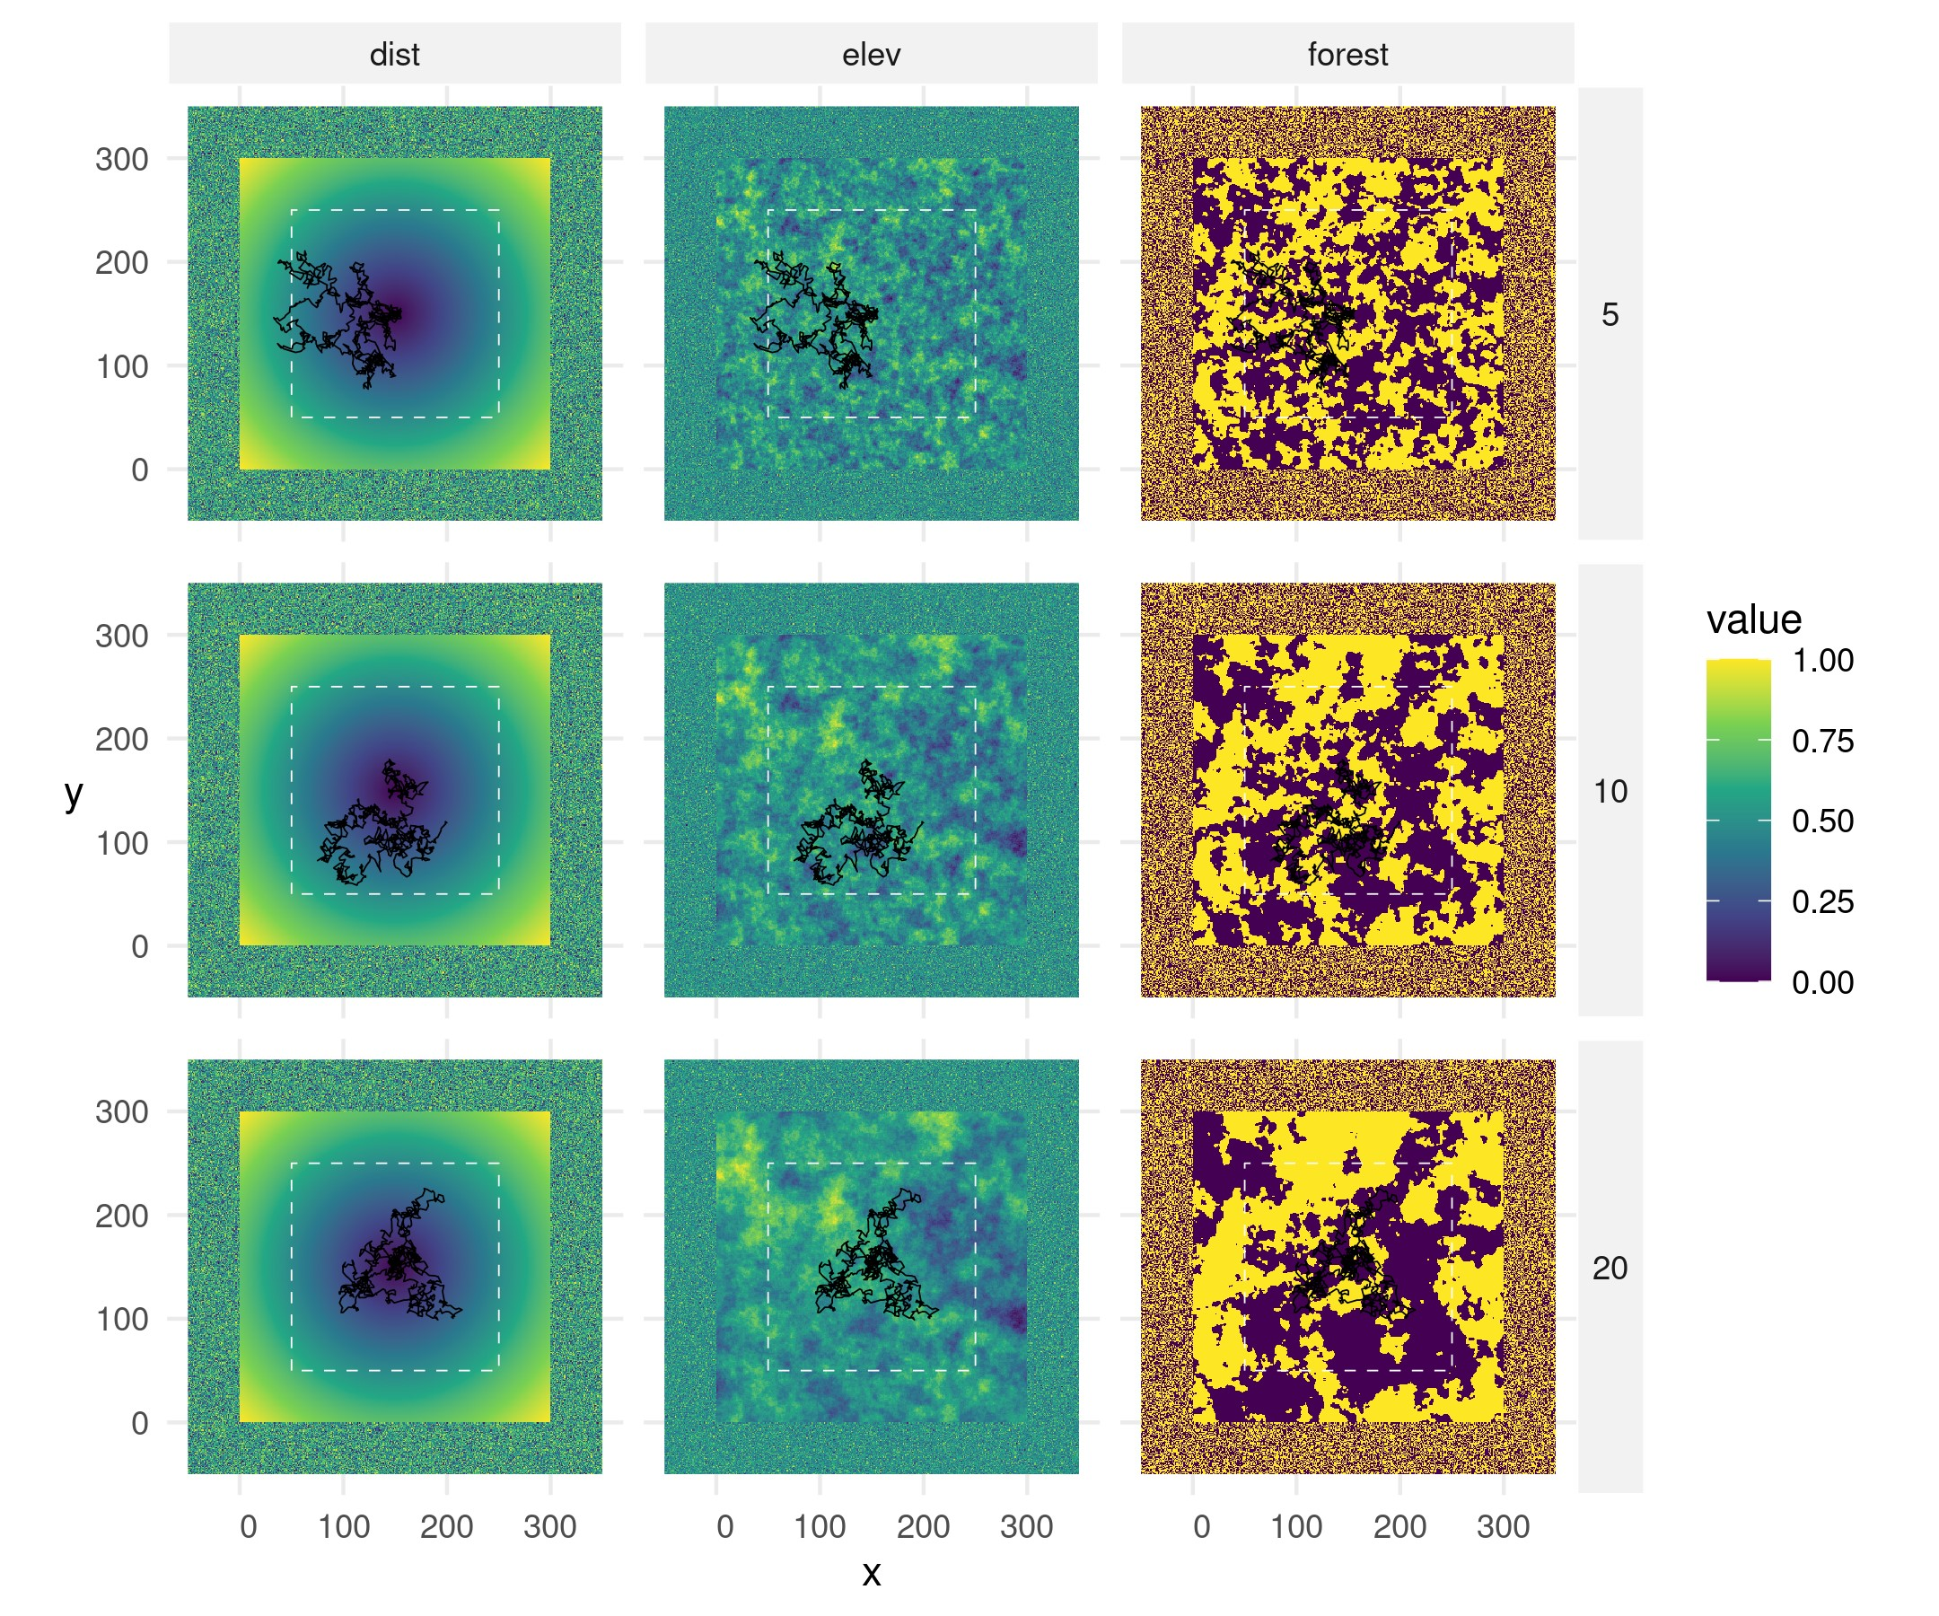

**Figure S1:** Simulated landscapes under different levels of autocorrelation (5, 10, 20; from top to bottom). Autocorrelation only affected the layers elev and forest, which were both simulated using a Gaussian random field neutral landscape model (Schlather et al., 2015) using the R-package NLMR (Sciaini et al., 2018). Note that the zone below and above x- and y-coordinates 0 and 300 served as buffer zone and contained randomized values from the simulated layers.

## A.2 Simulation of the Forest Layer

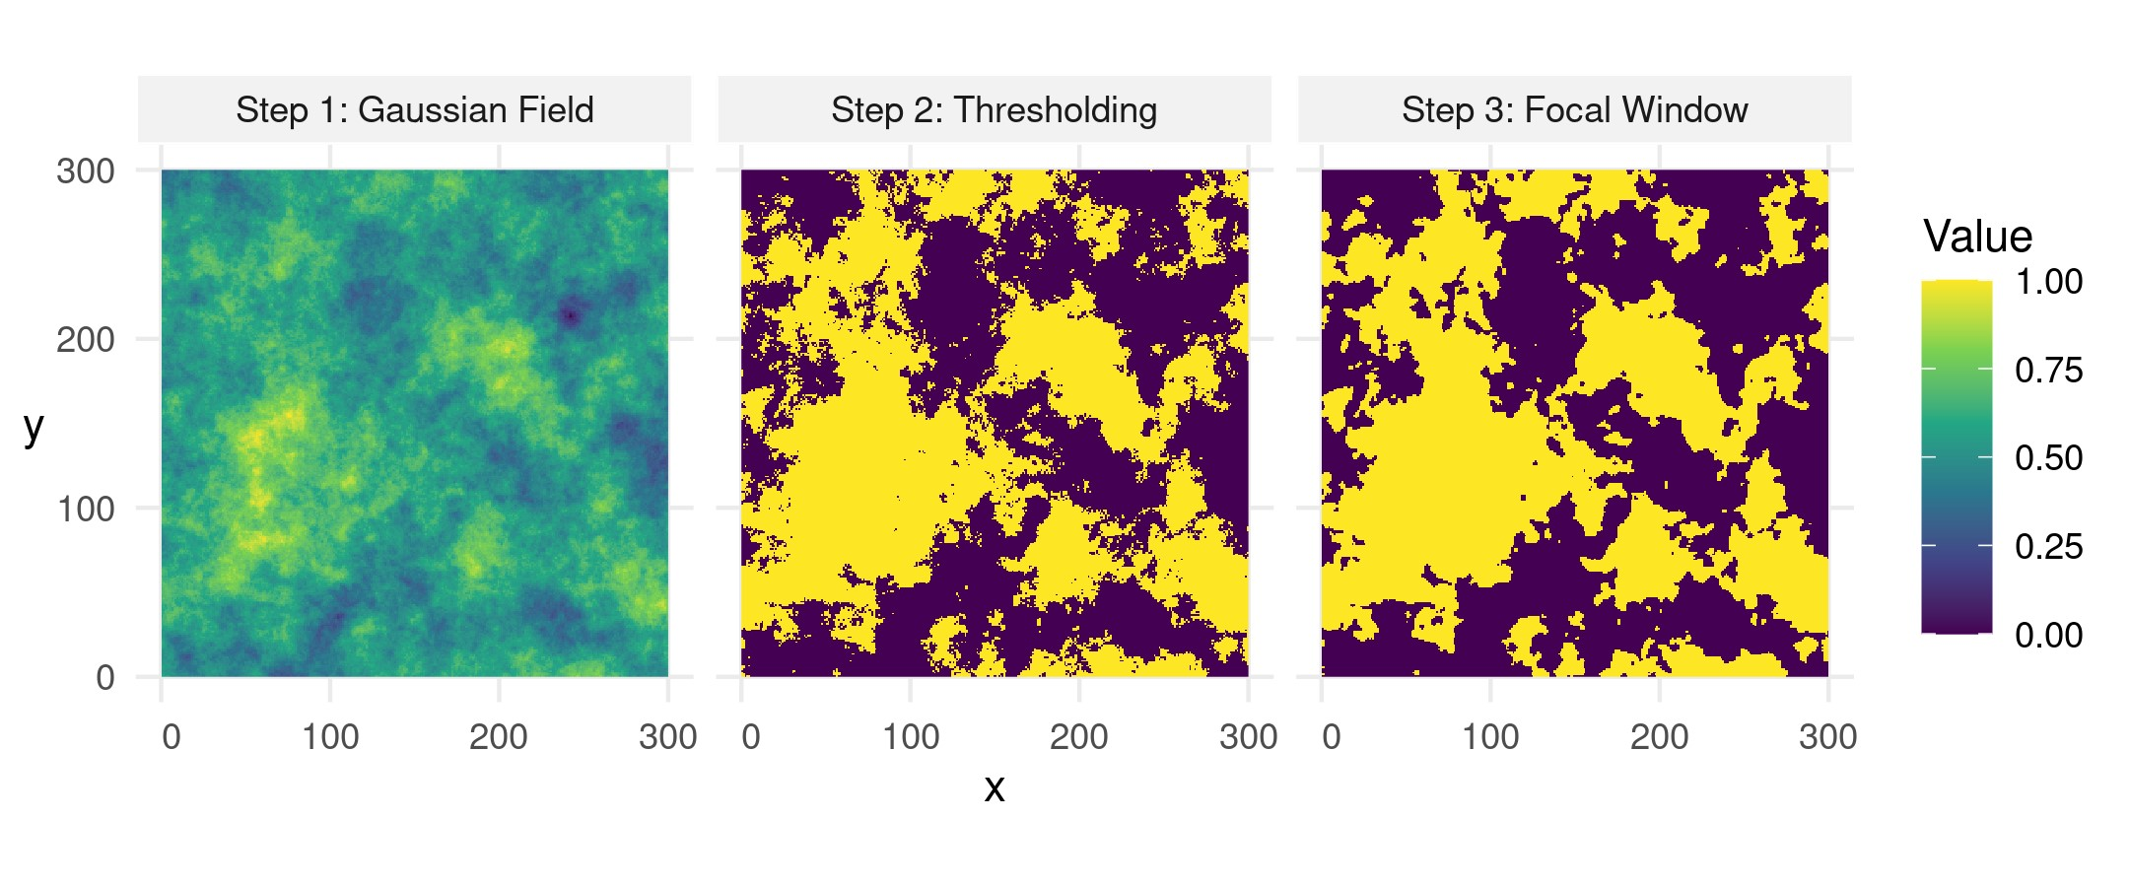

**Figure S2:** Illustration of the simulation of the forest layer. In Step 1, we simulated a gaussian field. In Step 2, we thresholded the layer into a binary image, containing 50% forest, and 50% non-forest. Ultimately, in Step 3, we cleaned forest borders using a moving window of 9 pixels whithin which we compute the modal value.

## A.3 Dynamic Distribution Parameters

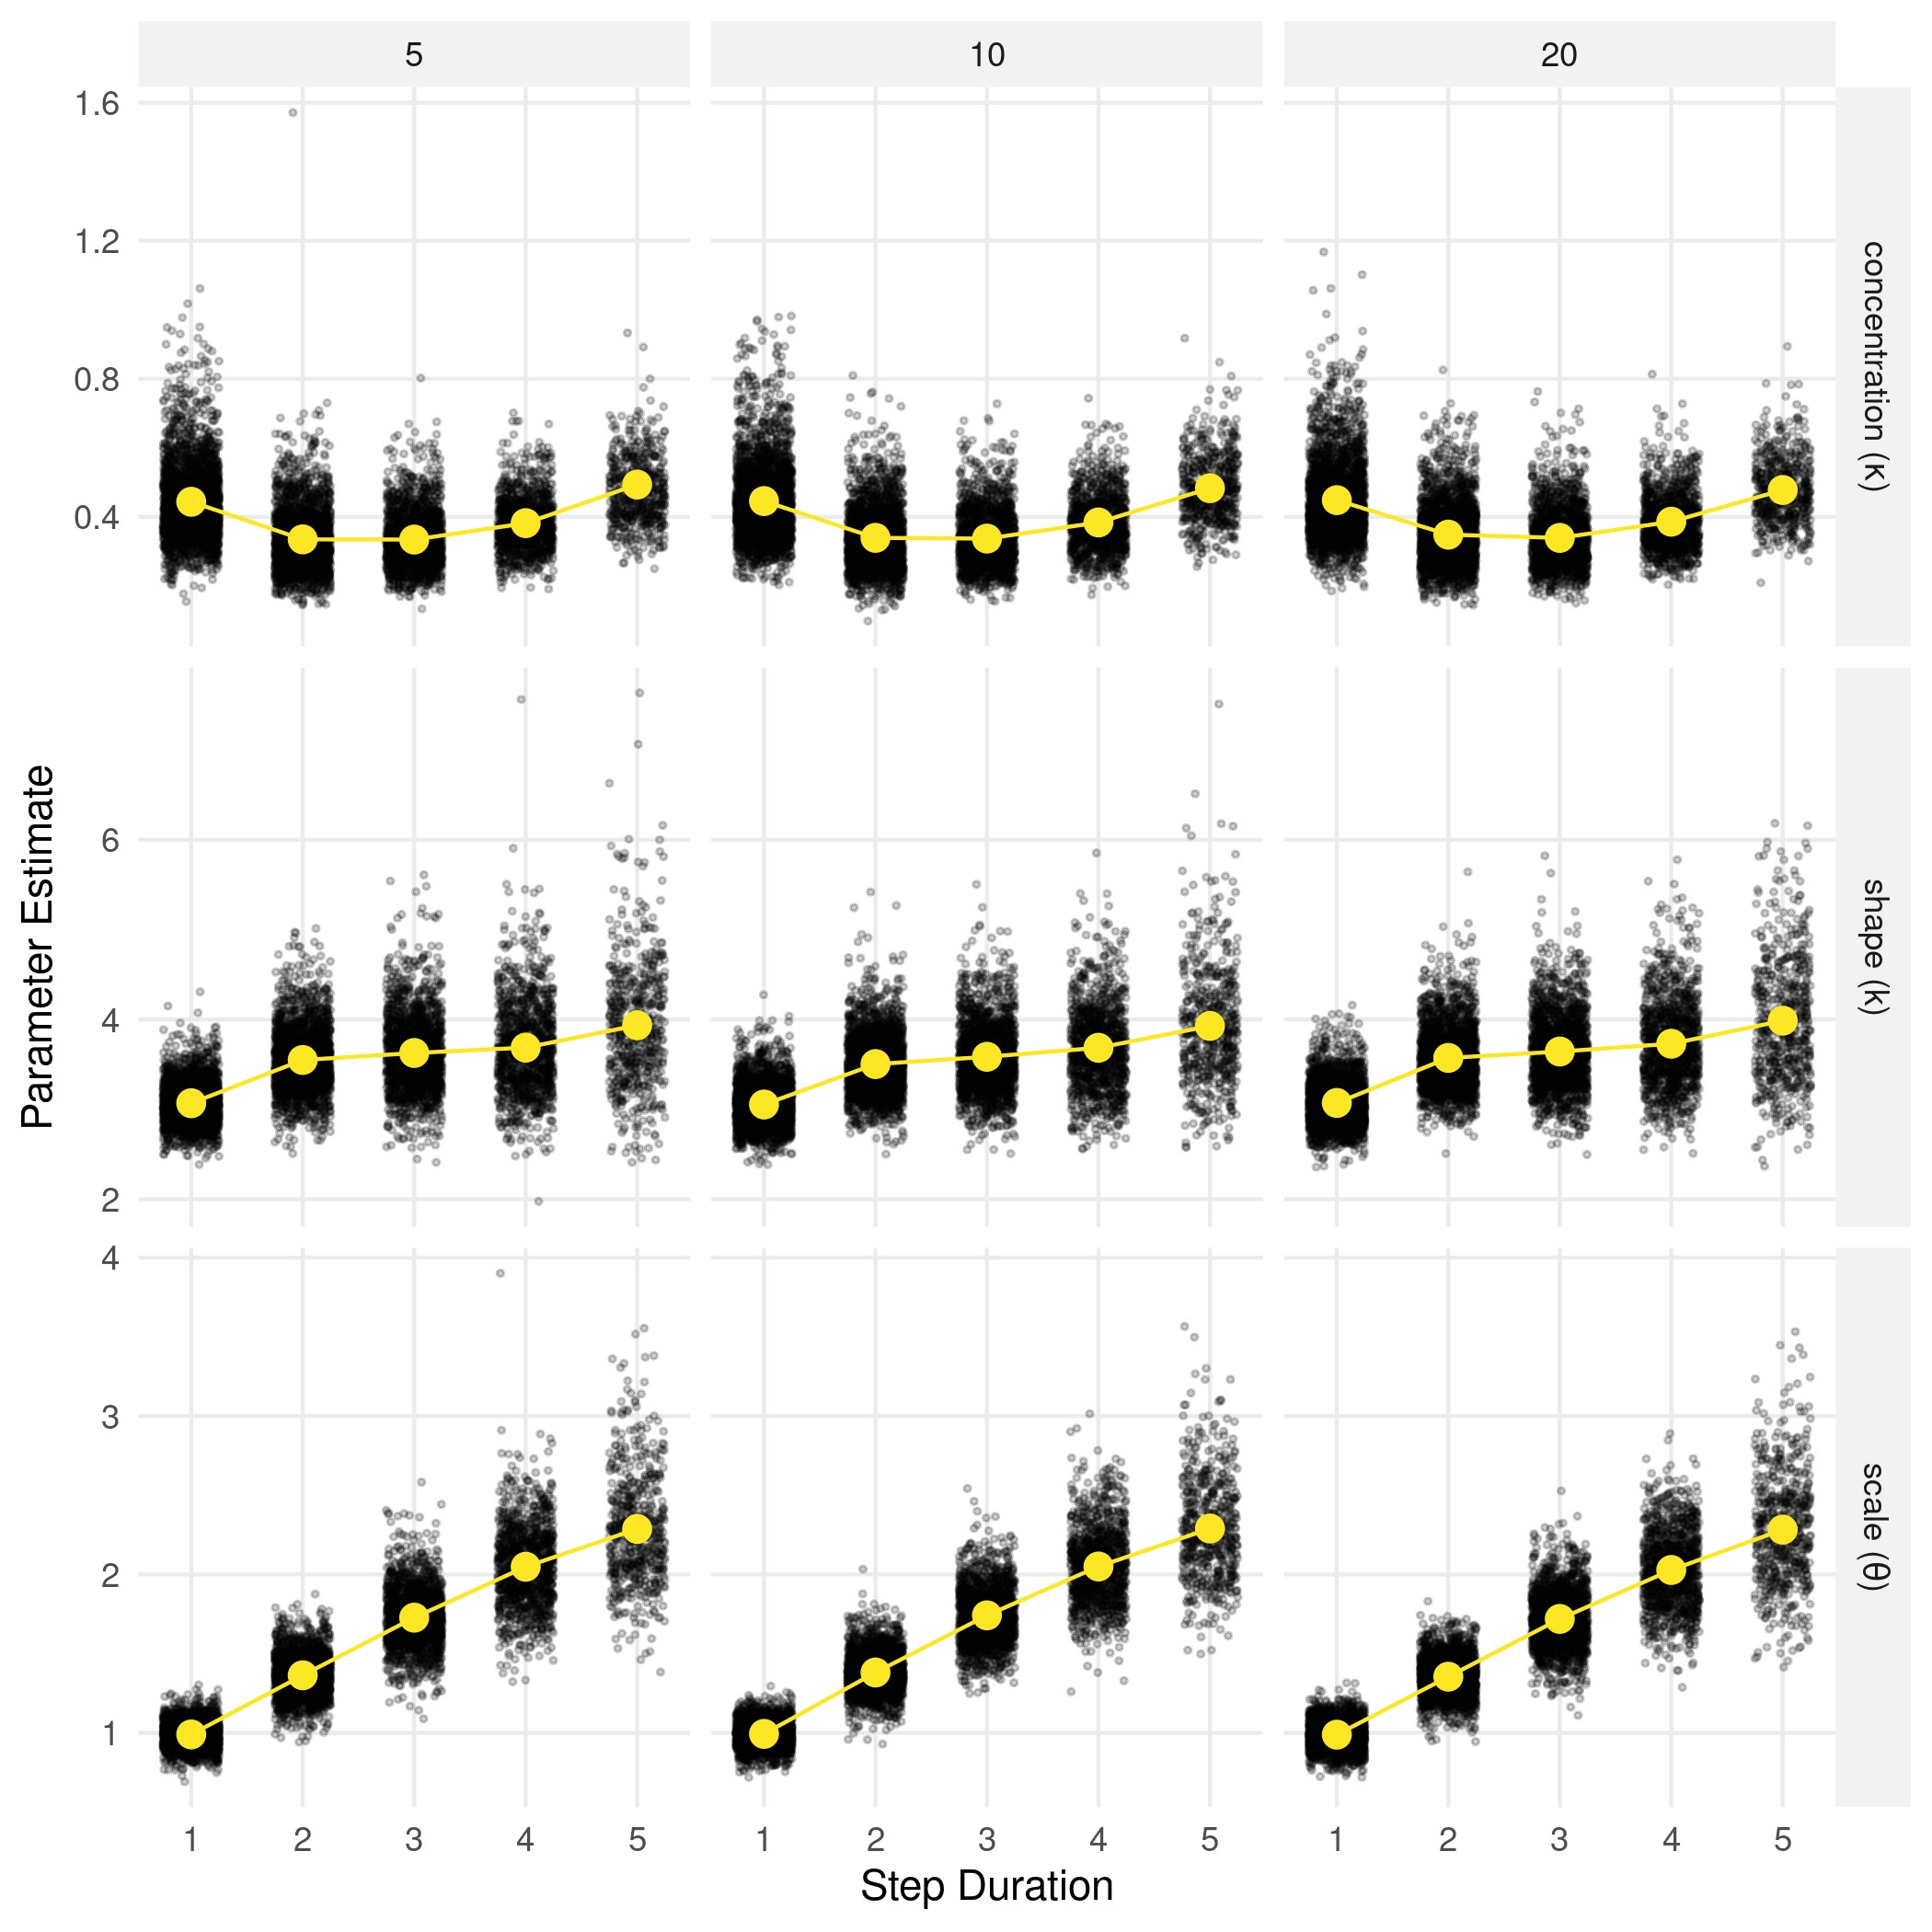

**Figure S3:** Parameter estimates for the von Mises distribution (top row) and gamma distribution (bottom row) fitted to steps with different durations. The von Mises distribution requires one parameter, namely a concentration parameter (*κ*). The gamma distribution requires a shape parameter (*k*) and a scale parameter (*θ*).

## A.4 Model Estimates across all Scenarios

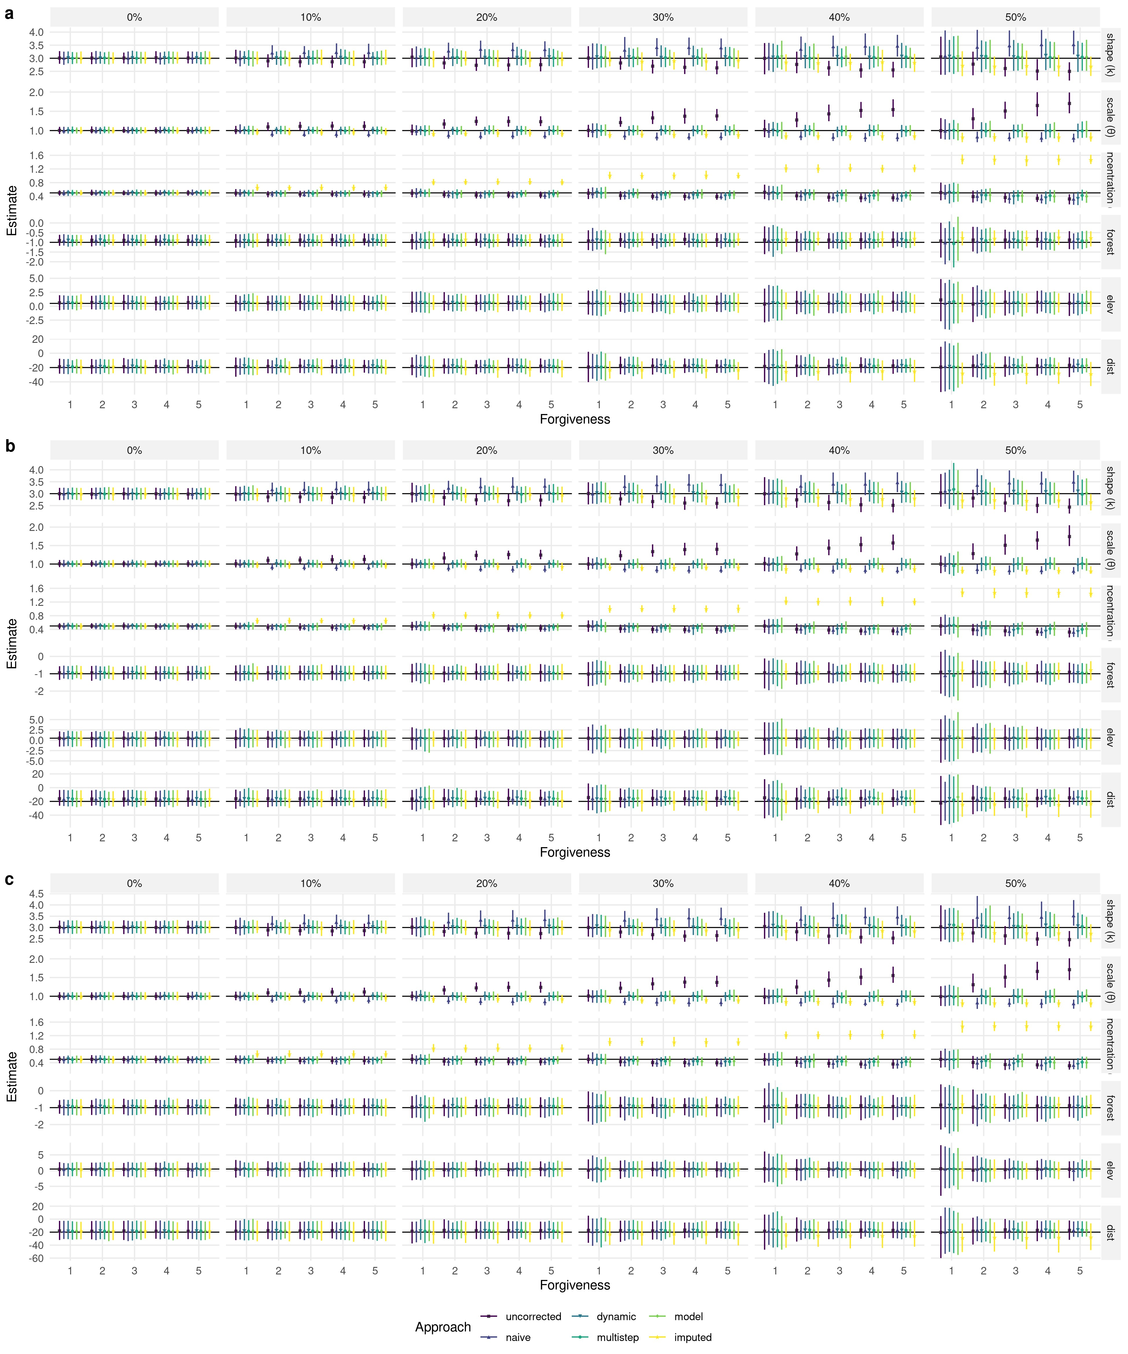

**Figure S4:** Parameter estimates across different autocorrelation scenarios (5, 10, 20; panels a, b, and c) and missingness levels (0% - 50%; from left to right). True simulation parameters are indicated by the solid black lines. Parameter estimates from the different approaches are given by the colored symbols, and their bootstrap 95% CIs across 100 replicates by the colored lines.

## References

Schlather, M., Malinowski, A., Menck, P. J., Oesting, M., and Strokorb, K. (2015). Analysis, Simulation and Prediction of Multivariate Random Fields with Package RandomFields. *Journal of Statistical Software*, 63:1–25.

Sciaini, M., Fritsch, M., Scherer, C., and Simpkins, C. E. (2018). Nlmr and Landscapetools: An Integrated Environment for Simulating and Modifying Neutral Landscape Models in R. *Methods in Ecology and Evolution*, 9(11):2240–2248.